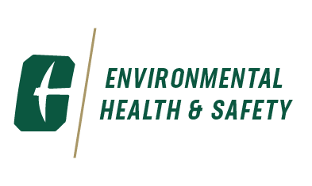
Environmental, Health and Safety
9201 University City Boulevard
Charlotte, NC 28223-0001
Phone: 704-687-1111 / Fax: 704-687-5302
As required by the Environmental Protection Agency (EPA) and the Clean Water Act (CWA), the requirements of the Spill Prevention, Control & Countermeasure (SPCC) Plan must be carried out immediately whenever there is a spill or release of petroleum based product, which could threaten human health or the environment.
To request a copy of the UNC Charlotte SPCC Plan, please contact the EHS Office at 687-1111.

